EVS CLASS TEST: A Busy Month
Date- 13/11/2025
F.M.-10
MCQ (1x3=3)
1. This material is not used by birds to build their nest,-
a. Twigs b. Leaves c. Cement
d. Grass
2. Eagles use their beak to tear and eat the prey, they have this kind of beak-
a. Chisel shaped beak
b. Slender beak
c. Broad based beak
d.Hooked beak
3. The total number of canines in adult human are
a. 4 b. 8 c.10 d. 12

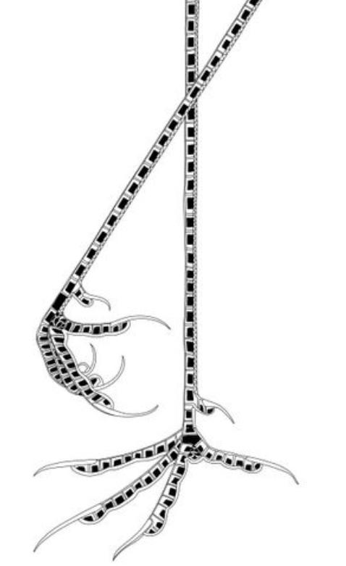
4. (i) Mention one use of the following feet. (1)
(ii) Identify the following type of tooth and write its use. (1+1)
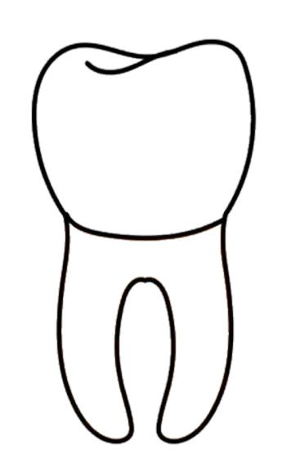
5.Write the importance of nests.(2)
6. Draw the diagram of an egg and label the embryo -forming part with name. (2)

